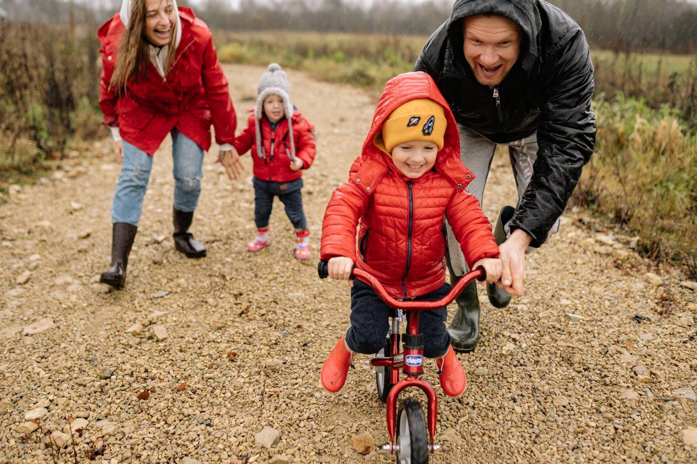
Photo via Pexels

Fitness Tips to Keep the Whole Family Moving

We all know that fitness is an important factor in our family’s quality of life. Unfortunately, it’s not always easy to keep moving when you’re stuck at home. It can be especially difficult to stay active if you work from home and have trouble stepping away from your computer. However, exercise can be a vital step in reducing stress at home, so it’s important to find time to move every day. And whether you’re staying indoors or can get outside (or at least the backyard), there are activities the whole family can enjoy together. Here are some ideas to get you started, courtesy of Dawson Flexible Fitness.

Be More Active

Wearing active clothing can help the whole family switch into a fitness mindset. Stock up on breathable, comfortable essentials for everyone. You can find online inspiration on any subject, and it’s true of fitness activities, too. From short video lessons to full-on at-home classes, go digital with your sweat session.

- Determine which fitness fabrics are best for your body and style.
- Ensure everyone has the right athletic wear, including shoes.
- Wash your workout gear carefully for long-lasting comfort.
- Explore family-friendly online-based exercise options.
- Print out a list of kid-safe fitness-focused ideas for any time.

Stock Up on Exercise Gear

Many exercises skip the equipment, but you might want a few essentials to maximize your workouts. From portable gear to smart tools for getting active, consider these fitness gear options.

- Invest in kettlebells, dumbbells, or a TRX suspension trainer.
- Look for low-cost tools like resistance bands for an easy way to mix things up.
- Talk to your healthcare providers before diving into any intense routines, especially for kids. Check your medical insurance coverage to see about consultation coverage and alternative options, like physical therapy or meeting with a nutritionist.
- Invite kids to compete with fitness video games to get them moving (and having fun).
- If you’re a dog owner, invest in quality items like a leash, collar and comfortable harness to keep your furry friend safe and secure during walks.

Simplify and Head Out

One of the best ways to get your family moving is to head outside. From simple games to long walks or bike rides, nature may be the right setting for your family fitness.

- Take a long walk to soak in nature, whether you’re exploring a park or running errands in town.
- Grab a ball and play any number of ball games (or make up your own rules).
- Why not plan fitness-friendly events with other families? Ramp up fun with a ballgame, group hike, or trip to a batting cage.
- Get everyone a fitness tracker and app, and create a family challenge for outside active time.

Get Active Together

Fitness can seem intimidating at first – especially when you’re spending more time at home. However, families can embrace more activity with these ideas. You can also come up with your own workout challenges to keep moving, both inside the house or out!

Dawson Flexible Fitness is here to help you get in shape and have fun doing it. Feel free to reach out if you have any questions!

